2024 AGM

Dé Domhnaigh 12ú Eanáir/ Sunday 12th January

@ 5:00pm in Galbally Community Centre

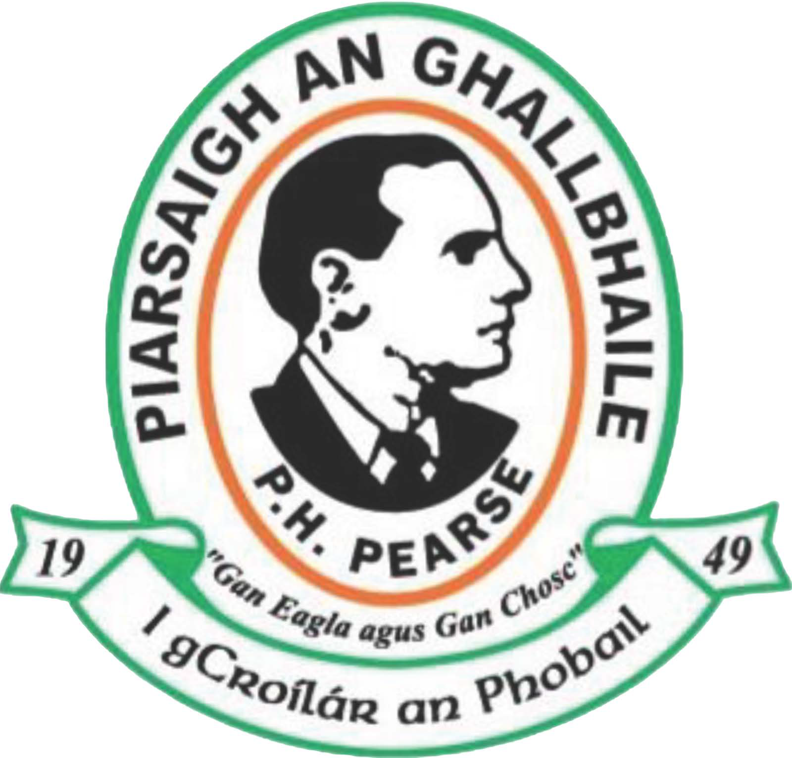

Nomination Forms Available

Online – Please Sign Electronically & Return To
secretary.galballypearses.tyrone@gaa.ie

Or Hard Copy - From Vivo Shop/Donnelly’s Post Office

All To Be Returned By 8pm On Sunday 29th December 2024

Nominations for 2025 Committee

Cathaoirleach

(Chairperson) (Outgoing): Noel McKeown) _____________________

Leas-Cathaoirleach

(Vice-Chairperson) (Outgoing): Pauline Bowman _____________________

Rúnaí

(Secretary) (Outgoing): Plunkett Nugent _____________________

Leas-Rúnaí

(Assistant-Secretary) (Outgoing): Michelle McCaul _____________________

Cisteoir

(Treasurer) (Outgoing): Dwyane Mulgrew _____________________

Leas-Cisteoir

(Assistant-Treasurer): _____________________

Oifigeach na nÓg

(Youth Officer) (Outgoing): Gavin McVeigh _____________________

Oifigeach Caidreamh Poibli

(PRO) (Outgoing): Carla McAuley _____________________

Leas-Oifigeach Caidreamh Poibli

(Assistant-PRO) (Outgoing): Paula Doherty _____________________

Oifigeach Phobail & Na Sláinte

(Health & Wellbeing Officer) (Outgoing): Louise Donaghy _____________________

Oifigeach Cultúrtha

(Cultural Officer) (Outgoing): Martina Jordan _____________________

Outgoing 2024 Committee Members
Conor Brannigan, Kieran Brannigan, Martin Brannigan, Brian Carberry

Eugene Carberry, Sean Carberry, Brendan Corrigan, Patrick Corrigan,

Declan Girvan, Ronan Hagan, Sean Hurson, Paul Kerr, John Moylan,

Peter Murphy, Pat McKeown, Francis O’Neill, Aiden Quinn, Declan Quinn
-------------------------------------------------------------

Nominations for 2025 Committee
(Members should confirm that those people they are nominating are willing to sit)

Na Ruin/Motions/Recommendations

